

(ISO 9001:2015 Certified), Accredited with ‘A’ Grade by NAAC

: 08258 - 281039 – 281263, Fax: 08258 – 281265

### Department of Computer Science and Engineering

B.E. CSE Program Accredited by NBA, New Delhi from 1-7-2018 to 30-6-2021

Report on Mini Project

To-Do-List

#### Course Code : 19CSE41 Course Name : Web Programming

##### Semester: V SEM Section : A

**Submitted To:**

## Dr. Sarika Hegde

## Associate Professor

## Department of Computer Science and Engineering

**Submitted By:**

**ADITHYA HOLLA K ADITYA MURUGAN**

**4NM19CS007 4NM19CS010**

**Date of submission: 30/12/2021**

#### Signature of Course Instructor

# ABSTRACT

Our day to day life is filled with lots of tasks as well as assignments. We

maybe assigned different deadlines so the completion of the work or tasks is necessary. The To Do List application provides a way to organize our tasks and reduce the confusion involved in it. The user can create an account in the registration page or login if an account already exists. They can then enter his tasks based on if the task is related to the profession or personal tasks.

The professional page contains the section for adding professional tasks. It

includes the task names and the deadline to finish it. User can use the email remainder facility available to remind about the tasks. The tasks also can be edited to change the task names. The personal page contains the section for listing personal tasks. The user is provided with a progress bar that he/she has to fill as they complete the tasks.

# TABLE OF CONTENTS

Title Page i

Abstract ii

Table of Contents iii

Introduction iv

Problem Statement v

Objectives vi

Hardware/Software Requirement vii

Methodology viii

Implementation Details x

Results xv

Conclusion and Future Scope xx

References xxi

# INTRODUCTION

# We all have those days when there are a million things to do, and we don’t

# know how we are going to get it all done.it is easy to become overwhelmed by

# the vast quantity of task that we must do form day to day. When we get too

# busy, we end up feeling like are barely able to keep our heads above water.

# We may not even complete the tasks that may have been easy to do and end up

# feeling stranded.

# Motivational speakers will tell us that to-do list are useful motivational tool.

# when used as a way to clarify goals. It help us to accomplish the goal can help

# clarify thought and give achievable short-term goals. As you succeed at each

# step along the way, you will gain confidence crossing items off your list. From

# to-do list we will be less stressed , more organized and find with more time in

# the day than you have realized.

# PROBLEM STATEMENT

# Social media and other easily accessible online distractions make it hard for

# us to stay focused on our task and make it difficult for us to do our work

# efficiently.

# Also, constantly switching between tasks may give us the false feeling that we

# are being productive when we are, in fact, not. It is more important for us to

# prioritize task and work on those that are most important , rather than focusing

# on deleting small items from our to-do list just for the sake of appearances

# OBJECTIVES

# The purpose of to-do list is set your mind at ease that you know the responsibilities are

# These are the prioritized list of all the task that you need to carry out.

# To help the user organize the task and meet deadlines.

# To provide the methods to prioritize their task.

# Realize the deadlines and work towards accomplishing goals.

# To provide user-friendly interface for all age groups.

# HARDWARE / SOFTWARE Requirements

**Software Requirements:**

**➢** IDE: Visual Studio Code Editor

➢ Client Side Technologies: HTML, CSS, JavaScript, Bootstrap

➢ Database Server: MYSQL, PHP

➢ Operating System: Microsoft Windows/Linux

**Hardware Requirements:**

➢ Processor: Pentium-3 or Higher

➢ RAM: 64MB or Higher

➢ Hard Disk: 80GB or Higher

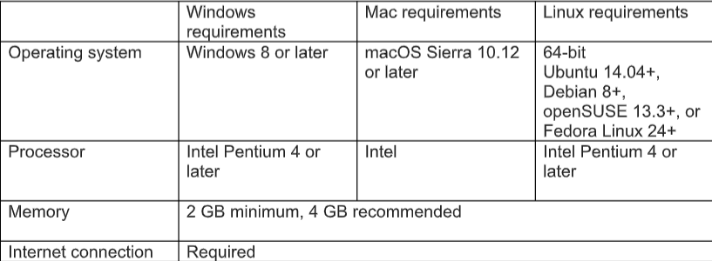

# METHODOLOGY

### Signup:

A table in the database has been created to store the user information. When the user wants to sign in with the site, he is directed to a HTML page where he enters his name, desired and unique User ID and Password. If it turns out to be valid his details are stored in the signup database that has attributes like name, User ID and password.

### Login/Logout:

The user enters his credentials in the login page, this data is checked with the signup database i.e., the User ID and password is matched with the existing records in the signup database. If it turns out to be true the user is allowed to use the functionalities of the web page.

**Professional to-do list page :**

The users enters his tasks which has to performed by the user . when the users enter the details of task which has to be completed by the user so user click the add button . it will display the title of task which has to completed by the user . it also display the details when task has to completed . In this page user also can edit or update the task . These changes also can be done by the user. So by seeing the details of this user can see the details and complete his task on priority.

**Personal to-do list page :**

The users enters his tasks which has to performed by the user . when the users enter the the details of task which has to be completed by the user ,so user click the add button . it will display the title of task which has to completed by the user . it also display the details when task has to completed . In this page user user can click on the task which has completed or not completed . it also contain progress bar so that when the task had been done by the user so that he can click the progress bar . from this user can conclude that how much tasks had been done . Here the user can do the task on their priorities .

**Remainder Section:**

Here the user write the message in the form as what type of task has to be done and when to complete . After completing the message the user click to send email. If the mail send to the user mail , the local host says the message has send successfully or not and we can see the remainder in the mail.

# IMPLEMENTATION

# Development environment:

* Visual studio code
* XAMPP Distribution

**Languages used:**

**FRONT-END:**

**HTML**:

HTML stands for Hypertext Markup Language. It is used to design web pages

using a markup language. HTML is the combination of Hypertext and Markup

language. Hypertext defines the link between the web pages. A markup language is used to define the text document within tag which defines the

structure of web pages. This language is used to annotate (make notes for the

computer) text so that a machine can understand it and manipulate text accordingly. Most markup languages (e.g., HTML) are human-readable. The language uses tags to define what manipulation has to be done on the text.

**CSS :**

CSS is the language we use to style an HTML document. It describes how HTML elements should be displayed.it describe how HTML elements It is easier to make the web pages presentable using CSS. It is easy to learn and understand and used to control the presentation of an HTML document. CSS helps us to control the text colour, font style, the spacing between paragraphs, sizing of columns, layout designs, and many more. It is independent of HTML, and we can use it with any XML-based markup language.

It is recommended to use CSS because the HTML attributes are being deprecated. So, for making HTML pages compatible with future browsers, it is good to start using CSS in HTML pages.

**JAVASCRIPT:**

JavaScript is a light-weight object-oriented programming language that is used by several websites for scripting the webpages. It is an interpreted, full-fledged programming language. JavaScript enables dynamic interactivity on websites when it is applied to an HTML document.

JavaScript helps the users to build modern web applications to interact directly without reloading the page every time. JavaScript is commonly used to dynamically modify HTML and CSS to update a user interface by the DOM API. It is mainly used in web applications.

**BACK-END:**

**PHP:**

The term PHP is an acronym for PHP: Hypertext Pre-processor. PHP is a server-side scripting language designed specifically for web development. It is open-source which means it is free to download and use. It is very simple to learn and use. The files have the extension “.php”. Rasmus Lerdorf inspired the first version of PHP and participating in the later versions. It is an interpreted language and it does not require a compiler. PHP code is executed in the server. It can be integrated with many databases such as Oracle, Microsoft SQL Server,

**Remainder Section:**

Here the user write the message in the form as what type of task has to be done and when to complete . After completing the message the user click to send email. If the mail send to the user mail , the local host says the message has send successfully or not and we can see the remainder in the mail.This is done by using java Script. If there is any error then local host that is invalid.

**Login Page:**

The user can login from here. It is implemented using sessions concept of PHP

where each successful login gives a session variable. The login page takes

attributes from a form which has been implemented using HTML and PHP. If

the user hasn’t logged in, he can visit the signup page through a link in login

page. After the user enters his credentials the username and password is

checked in the signup table. If the record matches in the table session variable

is set and is directed to that user account.

**Signup Page:**

The signup page offers a form through which user can sign-up. It is

implemented using Html form and php for adding the values to the database.

The user has to enter a unique User ID and the data are stored effectively in the

database. When a user signs up, a separate table is created in the name of the

user where all the details are stored.

**Professional to-do list page :**

The users enters his tasks which has to performed by the user . when the users enter the details of task which has to be completed by the user so user click the add button . it will display the title of task which has to completed by the user . it also display the details when task has to completed . In this page user also can edit or update the task . These changes also can be done by the user. So by seeing the details of this user can see the details and complete his task on priority. It is mainly implemented by PHP . All the details are stored in database . it also implemented by the CSS and HTML

**Personal to-do list page :**

The users enters his tasks which has to performed by the user . when the users enter the the details of task which has to be completed by the user ,so user click the add button . it will display the title of task which has to completed by the user . it also display the details when task has to completed . In this page user user can click on the task which has completed or not completed . it also contain progress bar so that when the task had been done by the user so that he can click the progress bar . from this user can conclude that how much tasks had been done . Here the user can do the task on their priorities. It is implemented by HTML, CSS and Javascript. It also contain the progress bar which is implemented by Javascript where the percentage of task can be updated.

**RESULTS AND DISCUSSIONS**

Index page:

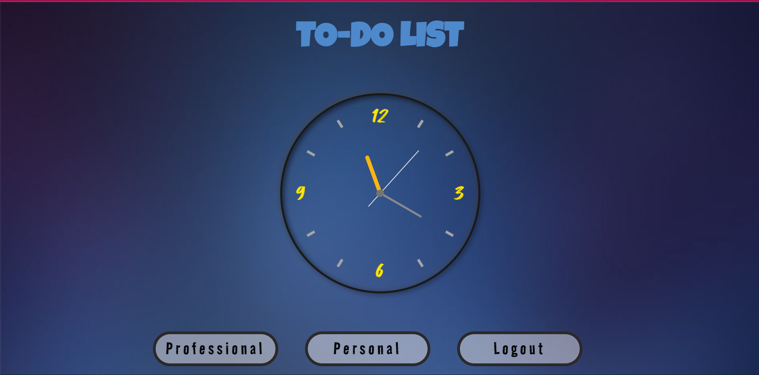

Professional page :

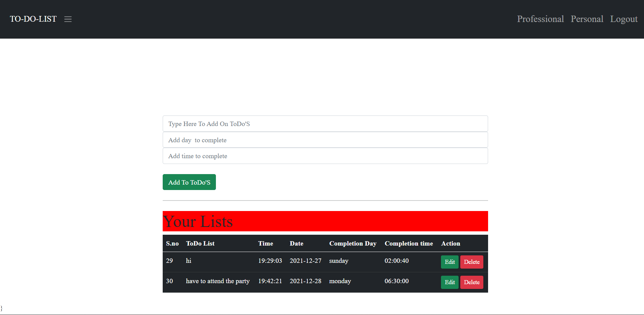

Personal page :

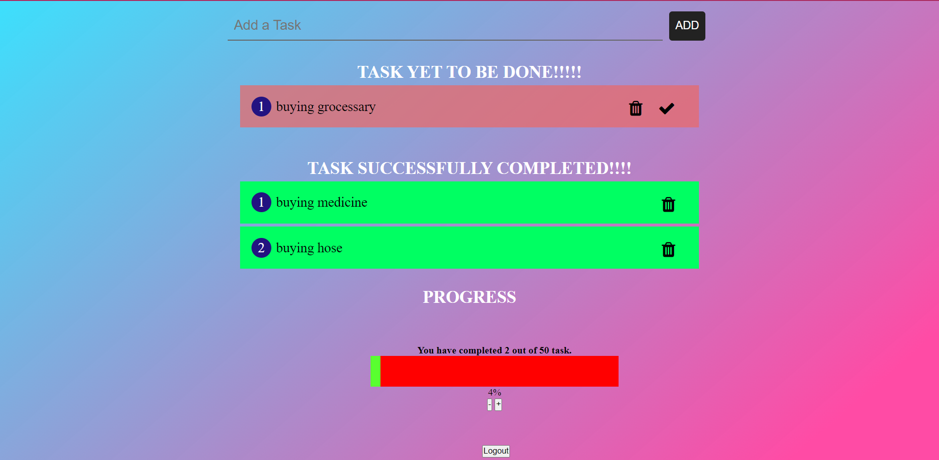

Login page:

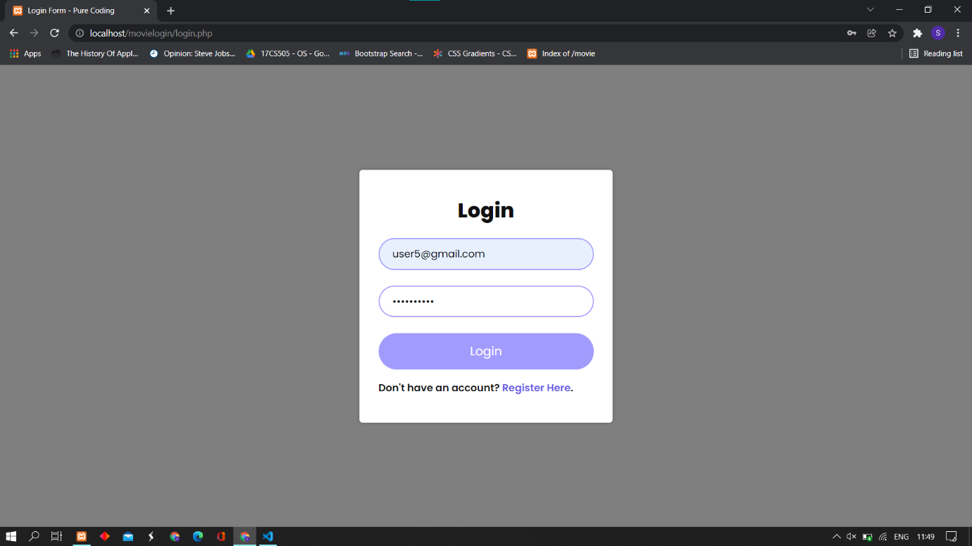

Registration form :

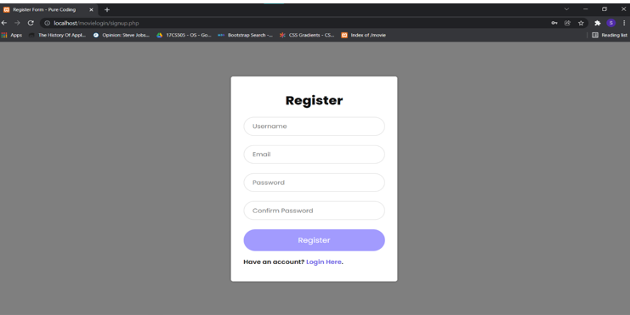

To-do list database:

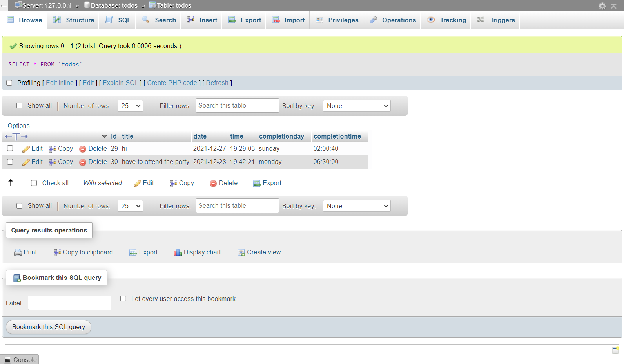

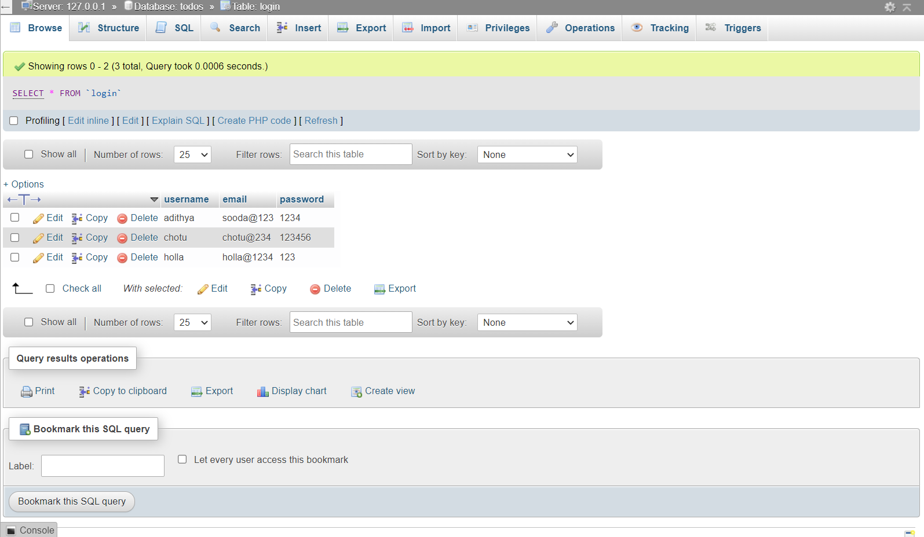

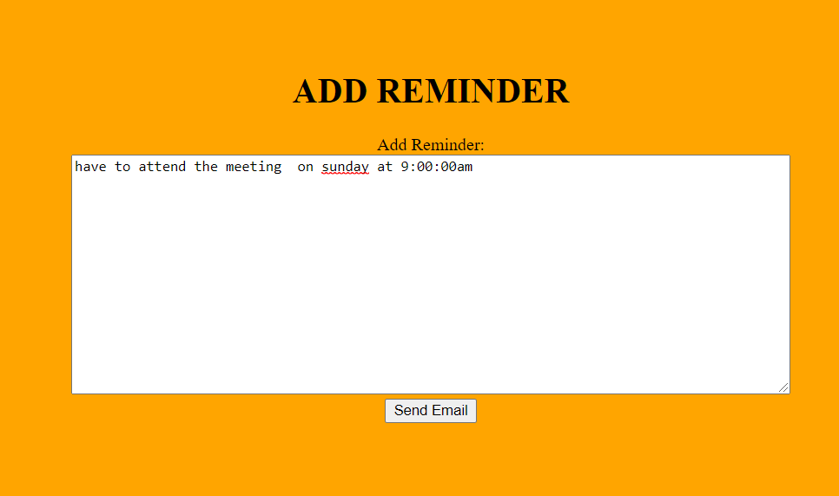

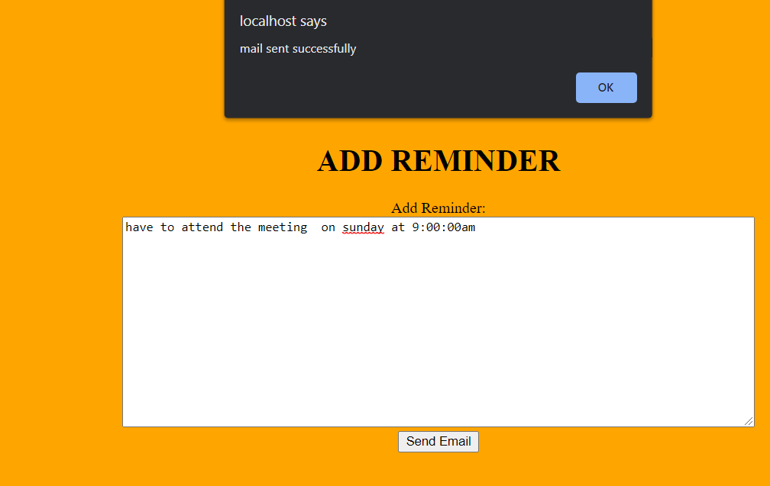

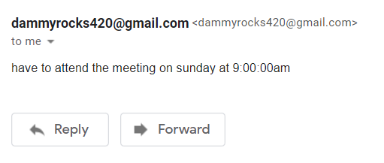

# CONCLUSION AND FUTURE SCOPE

Our daily life is filled with lots of works and tasks which we have to complete without fail.This application provides a way to achieve their goals and finish their work. It help us prioritize our task and reduces confusion with the amount of tasks that need to completed.The user has provided with various facilities as mentioned above. All the users needs to do is complete the task assigned. Since the voice recognition is very common in applications , it can be added to enhance the user application.

# REFERENCES

[**https://www.w3schools.com/tags/default.asp**](https://www.w3schools.com/tags/default.asp) **: W3Schools HTML reference**

[**https://www.w3schools.com/cssref/default.asp**](https://www.w3schools.com/cssref/default.asp) **: W3Schools CSS reference**

[**https://www.w3schools.com/js/default.asp**](https://www.w3schools.com/js/default.asp) **: W3Schools Javascript reference**

[**https://www.w3schools.com/bootstrap/default.asp**](https://www.w3schools.com/bootstrap/default.asp) **: W3Schools Bootstrap reference**

[**https://getbootstrap.com/docs/5.0/content/reboot/**](https://getbootstrap.com/docs/5.0/content/reboot/) **:** **Getbootstrap reference**

[**https://www.w3schools.com/php/default.asp**](https://www.w3schools.com/php/default.asp) **: W3Schools PHP reference**